AN
INTERNSHIP REPORT
On
Odoo Apps Ecosystem
Submitted
by
Dhruvi Jigneshkumar Shah
(Enrollment Number: 211430131058)
Guided By:
Prof. Priya Chaturvedi
An
Internship Report
Submitted to

Gujarat Technological University
In fulfillment for the award of degree of Bachelor of Engineering
in
CSE
ACADEMIC YEAR – 2024

NEW L. J. INSTITUTE OF ENGINEERING AND TECHNOLOGY
Pakwan, Behind Rajpath Club Gate to Sindhu Bhavan Road,
Sarkhej - Gandhinagar Hwy, AEC Char Rasta, Ahmedabad, Gujarat 380054



NEW L. J. INSTITUTE OF ENGINEERING AND TECHNOLOGY

CERTIFICATE

This is to certify that the Internship report submitted along with the project entitled Internship in ODOO IN PVT LTD has been Completed by Dhruvi Jigneshkumar Shah under my guidance in complete fulfilment for the Bachelor of Engineering in CSE Branch, 8th Semester of Gujarat Technological University, Ahmedabad during the academic year 2025.

Date:

Place: NEW LJIET, Ahmedabad.

Signature and Name of Guide  Prof. Priya Chaturvedi  Assistant Professor (CSE),  CSE Department,  NEW LJIET (143), Ahmedabad. | Signature and Name of H.O.D.  Dr. Gayatri Pandi.  CSE Department,  NEW LJIET (143), Ahmedabad.

Signature and Name of Principal
Dr. Gayatri Pandi.
NEW LJIET (143), Ahmedabad

Seal of Institute




NEW L. J. INSTITUTE OF ENGINEERING AND TECHNOLOGY

DECLARATION

We hereby declare that the Internship report submitted along with the Internship entitled Project Odoo Apps Ecosystem submitted in Complete for Bachelor of Engineering in CSE Branch to Gujarat Technological University, Ahmedabad, is a bonafide record of original Internship work Completed by me at ODOO IN PVT. LTD. under the supervision of External Guide Mohit Beniwal and that no part of this report has been directly copied from any students’ reports or taken from any other source, without providing due reference.

Name of Student  Dhruvi Jigneshkumar Shah | Signature of Student

ACKNOWLEDGEMENT


I wish to express my sincere gratitude to my External guide Mohit Beniwal for continuously guiding me at the company and answering all my doubts with patience. I would also like to thank Dr. Gayatri Pandi (H.O.D. of CSE) for motivating me every time whenever I get confused, I would also like to thank my Internal Guide Prof. Priya Chaturvedi for helping me through my internship by giving me the necessary suggestions and advices along with their valuable co-ordination in completing this Internship.

I also thank my parents, friends and all the members of the family for their precious support and encouragement which they had provided in completion of my work. In addition to that, I would also like to mention the company personals who gave me the permission to use and experience the valuable resources required for the Internship.

Thus, in conclusion to the above said, I once again thank the staff members of ODOO IN PVT. LTD. for their valuable support in completion of the Internship.

Thank You

Name of Student  Dhruvi Jigneshkumar Shah  Enrollment Number  211430131058 | Date:  Signature of Student

TABLE OF CONTENTS

CHAPTERS | PAGE NO.
Title Page | i
Certificate Page | ii
Internship Certificate | iii
Declaration | iv
Acknowledgements | v
Table of Contents | vi
Abstract | ix
CHAPTER 1  INTRODUCTION OF PROJECT & COMPANY PROFILE | 01
1.1 Introduction | 02
1.1.1 Company Profile | 02
1.1.2 Company Products | 02
1.1.3 Company Mission and Vision | 03
1.2 Introduction of the Project | 04
1.2.1 Purpose of the Project | 04
1.2.2 Function Requirements | 04
1.2.3 Problems in Existing System | 04
1.2.4 Main Modules | 05
CHAPTER 2 SYSTEM REQUIREMENTS | 06
2.1 Hardware & Software Requirements | 07
2.1.1 Hardware Requirements | 07
2.1.2 Software Requirements | 07
2.2 Functional Requirements | 07
2.3 Non Functional Requirements
CHAPTER 3 WORKSHEET REPORT | 09
3.1 WORK SHEET REPORT (15 DAYS) | 10
CHAPTER 4 FRONT END OF SYSTEM | 17
4.1 Introduction | 18
4.2 Test Case Image Generation and Visualization | 18
4.3 Graphical Insights and Image Comparisons | 20
4.4 Model Training Graphs | 21
4.5 Performance Evaluation Metrics
CHAPTER 5 BACK END OF SYSTEM | 24
5.1 Introduction | 25
5.2 Model Training and Architecture | 26
5.3 Logic of Generating Test Case Images | 27
5.4 Testing the Model on Transformed Images | 28
5.5 Final Performance Analysis and Evaluation Metrics | 30
CHAPTER 6 SYSTEM DESIGN | 35
6.1 System Analysis | 36
6.1.1 | 37
6.1.2 Needs of SDLC | 37
6.1.3 SDLC Cycle | 38
6.3 Spiral Model | 40
6.4 Class Diagram | 42
CHAPTER 7 DATA DICTIONARY | 44
7.1 Introduction | 45
7.2 Table | 48
CHAPTER 8 TESTING | 49
8.1 Testing Plan | 50
8.2 Testing Strategies | 52
8.3 Testing Method | 55
8.4 Test Case | 57
CHAPTER 9 SNAPSHOT OF WEBSITE | 60
9.1 Admin Site | 61
9.2 Users Site | 71
CHAPTER 10 ADVANTAGES | 73
10.1 Advantages | 74
10.2 Limitations | 74
CHAPTER 11 CONCLUSION AND FUTURE ENHANCEMENT | 76
11.1 Conclusion | 77
11.2 Future Enhancement | 77
BIBLIOGRAPHY | 79
- Course Outcome | 80
- Books | 81
- Web Reference | 81

Odoo Apps Ecosystem

Enrollment No.: 211430131058
Student Name: Dhruvi Jigneshkumar Shah

NEW L. J. INSTITUTE OF ENGINEERING AND TECHNOLOGY
(College Code:143)
Semester: VIII, CSE Department

ABSTRACT

The growing demand for intelligent space systems has led to the integration of Artificial Intelligence (AI) and Machine Learning (ML) for onboard satellite applications. This project, "Study and Development of Verification Flow for On-Board AI/ML-Based Application" focuses on developing and validating a verification flow to ensure the reliability of AI/ML models deployed in space. Given the constraints of satellite operations, where post-launch modifications are not feasible, rigorous pre-deployment testing is essential. In this study, various edge cases and test scenarios were developed using Python on the MATLAB platform to evaluate model robustness under real-world conditions. These test cases included brightness variation, blur, noise, occlusion, class imbalance, scaling, object displacement, zooming, colour inversion, compression artifacts, and transformations. The objective was to assess the model’s performance against diverse environmental and operational challenges that could impact onboard image detection accuracy. To replicate a space-like execution environment, the trained deep learning model was deployed and tested on FPGA hardware, ensuring that real-time constraints and computational efficiency were met. The verification process involved evaluating the model’s adaptability, accuracy, and resilience under different test scenarios, providing insights into its operational reliability. This work contributes to the broader goal of enhancing AI-driven space applications by establishing a structured verification framework. The findings will help improve model selection strategies, dataset preprocessing techniques, and hardware compatibility for onboard AI/ML-based image recognition systems. The study ensures that the deployed models maintain high precision and robustness, addressing challenges unique to satellite-based image detection.

CHAPTER: 1
INTRODUCTION OF PROJECT
&
COMPANY PROFILE

Introduction
    - Company Profile
    - Company Products
    - Company Mission and Vision
  - Introduction of the Project
    - Purpose of the Project
    - Function Requirements
    - Problems in Existing System
    - Main Modules

Introduction

    - Company Profile
Space Applications Centre (SAC), is a major research and development centre of the Indian Space Research Organisation (ISRO). It plays a key role in realizing the vision and mission of ISRO. Located at Ahmedabad, SAC is spread across two campuses having multi-disciplinary activities. The core competence of the centre lies in development of space borne and air borne instruments/payloads and their applications for national development and societal benefits. These applications are in diverse areas and primarily meet the communication, navigation and remote sensing needs of the country. Besides these, the centre also contributes significantly in scientific and planetary missions of ISRO like Chandrayan-1, Mars Orbiter Mission etc. The communication transponders developed at this centre for Indian National Satellite (INSAT) and Geo Synchronous Satellite (GSAT) series of satellites are used by the government and private sector for VSAT, DTH, internet, broadcasting, telephony etc. These satellites are instrumental in reaching remote parts of the country. The payloads for major navigation systems of the country - Indian Regional Navigation Satellite System (IRNSS) and GPS Aided Geo Augmented Navigation (GAGAN) are being developed by this centre. This centre designs and develops the optical and microware sensors for the satellites, signal and image processing software, GIS software and many applications for the Earth Observation (EO) programme of ISRO. These applications are in diverse areas of Geosciences, Agriculture, Environment and Climate Change, Physical Oceanography, Biological Oceanography, Atmosphere, Cryosphere, Hydrosphere etc.
    - Company Products
SAC is the leading centre for design and development of payloads for communication and navigation satellites. The first experimental communication satellite of India, 'APPLE' was designed, fabricated and qualified at SAC. It was launched onboard the first experimental flight of the Arian. Since then centre has developed strong competence in design and development of communication payloads. Satellite Communication payloads consists of transponders. Transponders for INSAT and GSAT series of satellites are designed in various bands of UHF, L, S, C, Ext. C, Ku and Ka bands. The Geo Stationary Satellite (GSAT) is the operational series of communications satellites which provides fixed satellite services for Indian civilian use. SAC designs and develops the various subsystems of a communications transponder.

Most of us are touched by satellite communication in more ways than we realise. Satellite communication (SATCOM) offers some unique benefits like, ubiquitous coverage, serving far flung areas, anywhere connectivity etc. In the past two and a half decades Indian National Satellite (INSAT) and GSAT systems have revolutionized the country's telecommunications, TV broadcasting, DTH services, business communications, rural area connectivity etc. The satellite communication technology has matured substantially over past three decades and is being used on commercial basis for a large number of applications.

Satellite Navigation (SATNAV) has revolutionized the navigation world, opening new opportunities which require high precision positioning and timing. Large service volume and all weather capability provide varieties of applications. Under satellite navigation, SAC is working on IRNSS - Indian Regional Navigation Satellite System and the GAGAN systems. IRNSS aims at providing Standard Position Services (SPS) and Restricted Services (RS) for special users.

    - Company Mission and vision
Mission
The Space Applications Centre (SAC), ISRO is committed to advancing space technology and developing innovative satellite-based applications to address national and global challenges. SAC plays a pivotal role in designing and deploying cutting-edge solutions in remote sensing, communication, navigation, meteorology, and space science to support strategic, societal, and economic development. Through continuous research, indigenous innovation, and collaboration, SAC aims to enhance India’s self-reliance in space technology, drive technological advancements, and contribute to sustainable development and global scientific progress.
Vision
To be a global centre of excellence in space applications and technology development, pioneering advanced satellite-based solutions for national growth, scientific discovery, and societal empowerment. SAC envisions leveraging space technology to foster innovation, strengthen India's position as a leader in the global space ecosystem, and create a future where space-driven solutions enhance the quality of life, enable sustainable development, and contribute to the betterment of humanity.

  - Introduction of the Project
    - Purpose of the Project
The primary objectives of, "Study and Development of Verification Flow for On-Board AI/ML-Based Application” are:
- Develop a structured verification flow for AI/ML-based image detection models used in satellite applications.
- Create and implement diverse edge cases (e.g., brightness variation, blur, noise, occlusion, scaling, etc.) using Python on MATLAB to assess model robustness.
- Ensure the AI model’s adaptability to real-world environmental variations by simulating different test scenarios.
- Validate the trained deep learning model by running it on FPGA hardware to study its performance.
- Analyse the impact of edge cases on model performance and refine the verification methodology to enhance reliability.
- Improve the overall validation process for AI/ML-based onboard applications, ensuring that models perform efficiently and accurately in satellite operations.

    - Function Requirements
- AI/ML Model Development & Selection: Selecting and training a deep learning model suitable for onboard image detection in satellites.
- Dataset Preprocessing & Augmentation: Implementing preprocessing techniques to improve model robustness against variations such as blur, noise, occlusion, scaling, and compression artifacts.
- Edge Case Testing: Creating various test cases using Python on the MATLAB platform to simulate real-world challenges faced by satellites.
- Hardware Deployment & Verification: Running the trained model on FPGA hardware to evaluate performance in resource-constrained environments.
- Performance Analysis & Optimization: Assessing the model’s accuracy, efficiency, and adaptability under different test scenarios.

    - Problems in Existing System
- Post-Launch Inflexibility: Once a model is deployed on a satellite, updates or modifications are not feasible, making pre-launch validation crucial.
- Environmental Variability: Space-based image recognition is affected by factors such as light fluctuations, motion blur, occlusion, and noise, which can degrade model performance.
- Current Validation Flow is Not AI/ML-Specific: Existing validation methodologies are primarily designed for traditional satellite-based image processing and lack AI/ML-specific testing strategies.

    - Main Modules
- Dataset Preprocessing & Augmentation: Enhancing training data by simulating real-world distortions and variations.
- Edge Case Generation & Testing: Developing Python-based test cases on MATLAB to validate the model’s performance under different conditions.
- Model Selection & Training: Comparing various deep learning models for suitability in onboard image detection.
- Hardware Implementation & Verification: Deploying the trained model on FPGA hardware to test real-time performance in constrained environments.
- Performance Evaluation & Optimization: Measuring accuracy, processing time, and resource utilization, ensuring the model meets onboard operational requirements.

CHAPTER: 2
SYSTEM REQUIREMENTS

2.1 Hardware & Software Requirements
2.1.1 Hardware Requirements
2.1.2 Software Requirements
2.2 Functional Requirements
2.3 Non-Functional Requirements

2.1 Hardware & Software Requirements
2.1.1 Hardware Requirements
- The hardware setup ensures efficient execution of the AI model while simulating real-world constraints. The following components are utilized:
- FPGA (Field-Programmable Gate Array): Used to run the trained AI model and analyze its performance in a space-like execution environment.

2.1.2 Software Requirements
- The Project involves multiple software tools for model development, testing, and verification.
- MATLAB: Used for implementing robustness test cases and evaluating model performance.
- Python: Utilized for developing edge case scenarios and running machine learning scripts.
- Deep Learning Frameworks (TensorFlow/PyTorch): For training and testing AI models.
- OpenCV: Used for image processing tasks like noise addition, blurring, and transformations.
- FPGA Development Tools: Software for deploying and running AI models on FPGA hardware.
- Image Acquisition Source: Dataset of satellite images for model training and validation.
  - Functional Requirements
- AI Model Training & Selection: Train deep learning models for onboard image detection.
- Image Processing & Augmentation: Simulate real-world variations (e.g., noise, brightness changes, scaling).
- Robustness Testing: Evaluate model performance against various test scenarios (blur, occlusion, compression, etc.).
- Hardware Execution: Deploy the trained model on FPGA and assess its real-time performance.
Performance Analysis: Measure accuracy, processing time, and adaptability of the model under different conditions.
  - Non-Functional Requirements
- Reliability: The model should consistently detect objects in satellite images under diverse conditions.
- Efficiency: The AI model must operate efficiently with FPGA hardware.
- Scalability: The system should support enhancements in datasets and model architectures.
- Robustness: The verification process should ensure the AI model remains resilient to environmental changes.

CHAPTER: 3
WORK SHEET REPORT

3.1 Work Sheet Report (15 DAYS)

3.1 Work Sheet Report (15 DAYS):

SUGGESTED 15 DAYS WORK SHEET REPORT
Student Name: |  |  | Mitrajsinh Mahendrasinh Padheriya
Enrollment No: |  |  | 211430131063
Internship/Project Title |  |  | Study & Development of Verification Flow for On-Board AI/ML Based Application
Tools and Technologies |  |  | - Python, Matlab
Company/ Organization Name |  |  | Space Applications Centre (SAC), ISRO
Student’s Activity Details:
Week  Number | Start Date to  End Date | Tasks to be assigned |  | Tasks to be completed | Remarks
1 | 20/01/2025  To  24/01/2025 | Study of Report regarding Onboard Implementation of Cloud Detection algorithm based on ML/CNN technique using Xilinx KU060 FPGA |  | Completed
2 | 27/01/2025  To  31/01/2025 | Study of various features in image processing and implementation of feature extractions using matlab |  | Completed

SUGGESTED 15 DAYS WORK SHEET REPORT
Student Name: |  |  | Mitrajsinh Mahendrasinh Padheriya
Enrollment No: |  |  | 211430131063
Internship/Project Title |  |  | Study & Development of Verification Flow for On-Board AI/ML Based Application
Tools and Technologies |  |  | - Python, Matlab
Company/ Organization Name |  |  | Space Applications Centre (SAC), ISRO
Student’s Activity Details:
Week  Number | Start Date to  End Date | Tasks to be assigned |  | Tasks to be completed | Remarks
3 | 3/02/2025  To  7/02/2025 | Study of challenges in image processing while training the deep learning models and identified validation checks during pre-processing. |  | Completed
4 | 10/02/2025  To  14/02/2025 | Front-end: Core JavaScript Study of verification flow used for testing of AI/ML based models.  Study of Simple Deep Learning Neural Network Model its hyperparameters, activation functions etc |  | Completed

SUGGESTED 15 DAYS WORK SHEET REPORT
Student Name: |  |  | Mitrajsinh Mahendrasinh Padheriya
Enrollment No: |  |  | 211430131063
Internship/Project Title |  |  | Study & Development of Verification Flow for On-Board AI/ML Based Application
Tools and Technologies |  |  | - Python, Matlab
Company/ Organization Name |  |  | Space Applications Centre (SAC), ISRO
Student’s Activity Details:
Week  Number | Start Date to  End Date | Tasks to be assigned |  | Tasks to be completed | Remarks
5 | 17/02/2025  To  21/02/2025 | Developed a deep learning model and tested the accuracy Over Different Parameter value  Front-end: CCS  Identified the factors To Consider While  Generating Image Dataset |  | Completed
6 | 24/02/2025  To  18/02/2025 | Validated Image data set for training and validation.  Developed edge case test cases for validation of model accuracy. |  | Completed

CHAPTER: 4
FRONT END OF SYSTEM

4.1 Introduction
4.2 Test Case Image Generation and Visualization
4.3 Graphical Insights and Image Comparisons
4.4 Model Training Graphs
4.5 Performance Evaluation Metrics

  - Introduction
The front-end of the system is responsible for visualizing, analyzing, and interpreting the results of the AI/ML-based image detection application. It provides insights into the performance of the trained model by displaying test case images, generating graphical comparisons, and showcasing evaluation metrics. This chapter discusses how test cases are generated, how different images are compared, and how performance metrics such as accuracy, precision, recall, and other evaluation parameters are analyzed.
  - Test Case Image Generation and Visualization
- To ensure the robustness of the model, various edge cases were introduced in the dataset.
- The system includes tools to visualize transformed versions, highlighting the effects of each modification.
- The following test cases were generated and displayed brightness variations, blurring, Noise addition, occlusion, class imbalance, scaling, zooming, object position variation, colour inversion, image compression, Perspective transformation.
  - Graphical Insights and Image Comparisons
- To quantitatively evaluate the differences among test images, the front-end system generates comparison graphs, including:
- Histogram Comparisons – Displaying pixel intensity distributions before and after applying transformations.
- Structural Similarity Index (SSIM) Graphs – Measuring how visually similar transformed images are to the original images.
- Feature Map Comparisons – Extracted feature representations of images before and after modifications to understand how transformations affect model perception.
  - Model Training Graphs
- During the training phase, the model undergoes multiple iterations to optimize its performance. The front-end system generates real-time graphs to track key training metrics, allowing for a clear visualization of how the model improves over time. These insights help in identifying trends, diagnosing potential issues such as overfitting or underfitting, and fine-tuning hyperparameters for optimal performance.
- The following graphs are generated to monitor training progress:
- Loss vs. Epoch Graph
- This graph represents how the model’s loss (error) decreases as training progresses over multiple epochs.
- The loss function measures the difference between the model’s predicted output and the actual ground truth.
- A steep decline in loss in the initial epochs indicates that the model is learning efficiently, while a plateau may suggest that the learning rate needs adjustment.
- If the loss remains high after several epochs, it could indicate issues such as poor model architecture, insufficient training data, or improper hyperparameters.
- The front-end allows zooming and interactive analysis to track fluctuations and sudden spikes in loss, which may be caused by unstable training or incorrect data labels.
- Accuracy vs. Epoch Graph
- This graph shows how the model’s accuracy improves over time as it learns from the training data.
- Accuracy is calculated as the percentage of correctly classified samples out of the total number of samples.
- A steady increase in accuracy indicates effective learning, whereas stagnation suggests the model is no longer improving and may need adjustments.
- If the accuracy suddenly drops after a certain number of epochs, it might indicate overfitting, where the model memorizes training data instead of generalizing.
- The front-end provides an overlay of training accuracy vs. validation accuracy, helping to visualize if the model is performing well on both training and unseen validation data.

  - Performance Evaluation Metrics
- It provides a detailed evaluation of model performance through various metrics, including:
- Confusion Matrix – A heatmap representation of actual vs. predicted classifications to analyze model misclassifications.
- Intersection over Union (IoU) – Measures the overlap between predicted and ground truth bounding boxes.
- Precision, Recall, and F1 Score – Determines the balance between correctly detected objects and false detections.
- Accuracy – Provides an overall measure of how many predictions are correct.
- Mean Average Precision (mAP) – Evaluates object detection performance across different confidence thresholds.

CHAPTER: 5
BACK END OF SYSTEM

5.1 Introduction
5.2 Model Training and Architecture
5.3 Logic of Generating Test Case Images
5.4 Testing the Model on Transformed Images
5.5 Final Performance Analysis and Evaluation Metrics

5.1 Introduction
The back-end of the system is responsible for handling the computational aspects of the AI/ML-based image detection application. It includes model training, test case generation, processing pipelines, and performance evaluation. This chapter provides insights into the model architecture, the logic behind generating diverse test case images, and the final performance analysis, ensuring the model’s robustness before deployment in an onboard satellite system.
5.2 Model Training and Architecture
- The deep learning model used for satellite image detection was trained using a structured pipeline to ensure accuracy, robustness, and generalizability. The model was designed with multiple layers to extract meaningful features from images.
- Model Architecture and Layers
- The selected deep learning model consists of the following key layers:
- Input Layer: Accepts raw satellite images after preprocessing (resizing, normalization, and transformation).
- Convolutional Layers: Extract spatial features such as edges, textures, and shapes.
  - Uses kernels/filters to detect patterns in different scales.
  - Employs stride and padding techniques for better feature extraction.
- Batch Normalization: Ensures stable training by normalizing activations, improving convergence speed.
- Activation Functions (ReLU, SoftMax, or Sigmoid):
  - ReLU (Rectified Linear Unit) is used in hidden layers to introduce non-linearity and improve feature learning.
  - SoftMax (for multi-class classification) or Sigmoid (for binary classification) in the final layer provides probability-based predictions.
- Pooling Layers (Max Pooling / Average Pooling): Reduce spatial dimensions, retaining only the most significant features while lowering computational costs.
- Fully Connected Layers (Dense Layers): Flatten extracted features and pass them through fully connected neurons to make predictions.
- Dropout Layer: Prevents overfitting by randomly deactivating a fraction of neurons during training.
- Output Layer: Generates the final classification or object detection results.

- Model Training Process
- The model was trained using a large dataset of satellite images, following these steps:
- Data Pre-processing: Image augmentation (rotation, flipping, normalization) was applied to enhance generalization.
- Batch Processing: Training was done in mini-batches to improve computational efficiency and stability.
- Evaluation on Validation Data: Performance was continuously monitored using validation accuracy and loss metrics.
- Early Stopping: Training stopped when validation loss started increasing, preventing overfitting.
5.3 Logic of Generating Test Case Images
- To validate the model’s robustness, various edge cases were created by applying transformations to original images. The logic behind generating these test cases is as follows:
- Brightness Variation: Simulated different lighting conditions using gamma correction.
- Blurring: Applied Gaussian and motion blur to check detection capability in unfocused images.
- Noise Addition: Introduced Gaussian noise and salt-and-pepper noise to test resilience against interference.
- Occlusion: Partially covering objects to see if the model can still recognize patterns.
- Class Imbalance: Adjusting dataset distributions to evaluate model bias toward dominant classes.
- Scaling and Zooming: Enlarging or shrinking objects to check if the model detects different object sizes correctly.
- Object Position Variations: Moving objects to different locations within the image to test spatial robustness.
- Colour Inversion: Converting images to negative mode to see if the model can generalize features independent of colour.
- Compression Artifacts: Reducing image quality to evaluate how well the model performs with limited-resolution inputs.
- Geometric Transformations: Rotating, flipping, and warping images to test viewpoint variations.

5.4 Testing the Model on Transformed Images
- After training, the model was tested using the generated test case images to evaluate its real-world applicability. The process followed these steps:
- Running Inference on Each Test Case
- The trained model was loaded and tested on each transformed image.
- Predictions were recorded for each transformation to analyse how model confidence and accuracy changed.
- Comparison with Original Images
- The front-end displayed test images alongside their predicted outputs.
- Structural Similarity Index (SSIM) and histogram comparisons were used to assess how modifications impacted feature extraction.
5.5 Final Performance Analysis and Evaluation Metrics
- To quantify the model’s overall effectiveness, several performance evaluation metrics were calculated:
- Classification and Detection Performance
- Confusion Matrix:
  - Helps in identifying which classes are frequently misclassified.
- Accuracy: Measures the overall correctness of predictions.
- Precision, Recall, and F1 Score:
  - Precision: Percentage of correctly identified objects out of total detected.
  - Recall: Percentage of actual objects that were correctly identified.
  - F1 Score: A balance between precision and recall for an overall performance measure.
- Object Detection Performance
- Intersection over Union (IoU):
  - Measures overlap between predicted and actual object locations.
  - Higher IoU values indicate better localization accuracy.
- Mean Average Precision (mAP):
- Evaluates object detection across multiple confidence levels.
- A higher mAP score indicates superior detection capabilities.

CHAPTER 6
SYSTEM ANALYSIS AND SYSTEM DESIGN

6.1 System Analysis
6.1.1 Objectives of System Analysis
6.1.2 Problems in the Existing System
6.1.3 Proposed System
6.2 System Design
6.2.1 Design Consideration
6.2.2 System Architecture

6.1 System Analysis
System analysis is the process of assessing the current system’s limitations and defining the structure of the proposed system to meet functional and performance requirements efficiently. System analysis focuses on designing a verification framework for AI/ML-based image detection applications used in satellite-based environments. The goal is to ensure that AI models deployed onboard satellites can operate accurately under various real-world conditions.
    - Objectives of System Analysis
- Understanding AI Model Verification Challenges: Identifying the challenges in traditional AI/ML validation approaches and how they affect onboard satellite applications.
- Defining a Robust Verification Flow: Establishing a structured approach to systematically test and validate deep learning models for satellite-based image detection.
- Ensuring Real-World Robustness: Incorporating diverse test cases, such as contrast variations, distortions, perspective transformations, and object movement, to analyse model performance in realistic scenarios.
- Optimizing for FPGA Execution: Validating AI models on FPGA hardware to assess real-time processing capabilities and limitations.
- Enhancing AI Model Decision-Making: Providing an efficient evaluation framework with comprehensive performance metrics, including IoU (Intersection over Union), Precision, Recall, F1-score, and mAP (Mean Average Precision).

    - Problems in the Existing System
- Lack of Standardized Verification for Onboard AI: Traditional validation approaches focus on software-based applications and are not optimized for real-time AI execution in satellite environments.
- Challenges in Handling Real-World Variations: Existing systems do not adequately test AI models against brightness variations, object scaling, motion blur, or perspective distortions. These real-world conditions significantly impact model accuracy and decision-making capabilities.
- Post-Launch Modification: Once a model is deployed on a satellite, updates or modifications are not feasible, making pre-launch validation crucial.
    - Proposed System
The proposed verification framework overcomes the limitations of traditional AI model validation by introducing a structured and automated verification flow:
- Test Case Generation
  - The system applies test cases (scaling, rotation, distortion, blur, etc.) to satellite images before model inference.
  - It simulates real-world conditions that AI models may encounter when deployed onboard satellites.
- AI Model Execution and Evaluation:
  - The trained deep learning model processes the modified images, and its performance is analyzed based on object detection accuracy.
  - The system compares model outputs after applying test cases to determine performance degradation.

6.2 System Design
System design defines the architecture, components, and data flow of the AI model verification framework. This phase ensures that the system is efficient, scalable, and modular for real-time validation.

    - Design Considerations
- The design of the verification system is guided by the following considerations:
- Scalability: The system must support multiple AI models and new test cases without requiring major modifications.
- Modularity: The system is divided into independent modules for preprocessing, AI model execution, and performance evaluation, making it easier to update and maintain.
- Efficiency: Optimized execution of test cases.

    - System Architecture
The architecture consists of three major layers that define how data flows through the verification framework.
- Input & Preprocessing Layer
- Inputs: Satellite images are fed into the system for preprocessing.
- Preprocessing: The system applies various transformations to test model robustness, including:
- Scaling Up/Down
- Perspective Transformation
- Rotation & Distortion
- Blur (Motion and Gaussian)
- Contrast & Color Inversion
- Object Movement Simulation
- Normalization: The processed images are converted into a format suitable for AI model input.

- AI Model Execution Layer
- Model Loading: The trained AI model is loaded and applied to the original and preprocessed images.
- Inference Generation: The model predicts objects.
- Comparison: The system compares results from the modified images against the baseline predictions (ground truth).
  - Performance Evaluation & Reporting Layer
- Accuracy Metrics: The system calculates key metrics, including:
  - IoU, Precision, Recall, F1-score, and mAP.
- False Positive & False Negative Analysis:
  - False positives occur when the model detects objects incorrectly.
  - False negatives occur when the model misses detecting actual objects.
- Results Visualization:
  - The framework generates detailed reports and performance graphs for analysis.

CHAPTER: 7
DATA DICTIONARY

7.1 Introduction
7.2 Table

7.1 Introduction
The data dictionary provides a comprehensive and structured reference for defining key data elements used in the AI/ML-based image detection verification system. It serves as a centralized documentation source to understand the attributes associated with image preprocessing, transformations, performance evaluation metrics, and detection outcomes. By maintaining standardized definitions, it ensures clarity in data interpretation, improves interoperability between different components of the system, and streamlines the verification process. It provides a structured approach to data management, ensuring efficient analysis and evaluation of AI/ML-based image detection models. Additionally, it enhances traceability and reproducibility in testing, contributing to more reliable model validation and performance optimization.

7.2 Table:

Field Name | Description | Data Type | Size/Format | Example Value
Image_ID | Unique identifier for each image | Integer | Auto-generated | 1001
Image_Name | Name of the image file | String | 255 characters | "satellite_image_01.jpg"
Image_Format | Format of the image (JPEG, PNG, etc.) | String | 10 characters | "JPEG"
Resolution | Resolution of the image | String | Width x Height | "1024x1024"
Scaling | Factor by which the image is scaled | Float | 0.1x - 10x | 2.0x
Class Imbalance Handling | Method used to handle imbalanced classes | String | 50 characters | "Oversampling"
Object Movement | Change in object position in the image | String | X, Y coordinates shift | "(50, -30)"
Zoomed | Zoom level applied to the image | Float | 0.1x - 5x | 1.5x
Colour Inversion | Whether image colors are inverted | Boolean | Range:0-255 | 150
Contrast | Level of contrast applied to the image | Float | 1>high contrast  1<low contrast | 0.8
Perspective Transformation | Perspective warp applied to the image | Float | Skew factor | 5
Rotation | Rotation angle applied to the image | Float | Degrees (0-360) | 45°
Distorted | Type of distortion applied | Float | 1.2x-10x | 1.5x
Blur_Level | Degree of blur applied based on kernel size | String | Kernel size (3x3, 5x5, 7x7) | "5x5"
Blur Type | Type of blur applied | String | 30 characters | "Motion Blur"
IoU | Intersection over Union (IoU) score | Float | 0.0 - 1.0 | 0.75
Precision | Precision score of the model | Float | 0.0 - 1.0 | 0.85
Recall | Recall score of the model | Float | 0.0 - 1.0 | 0.90
F1-Score | Harmonic mean of precision and recall | Float | 0.0 - 1.0 | 0.875
mAP | Mean Average Precision | Float | 0.0 - 1.0 | 0.88
Detected_Objects | List of objects detected by the AI model | String | Variable length | cloud
False_Positive_Count | Number of false detections | Integer | 0+ | 2
False_Negative_Count | Number of missed detections | Integer | 0+ | 1
Accuracy | AI model accuracy in percentage | Float | 0 - 100% | 92.5%

CHAPTER:8
TESTING

8.1 Testing Plan
8.2 Testing Strategies
8.3 Testing Method
8.4 Test Case

8.1 Testing Plan
The testing phase is a crucial step in the verification flow of the on-board AI/ML-based application for satellite image detection. The primary objective of the testing plan is to ensure the robustness, accuracy, and reliability of the deployed AI model under various real-world conditions. The testing framework is designed to evaluate model performance under different edge cases, simulate operational constraints, and validate it.
- Objectives of the Testing Plan:
- Verify the AI model’s ability to handle real-world image variations.
- Ensure the model performs optimally on FPGA hardware.
- Evaluate the model’s robustness against adversarial conditions such as noise, occlusion, and transformations.
- Assess classification accuracy and computational efficiency under different scenarios.
- Ensuring accuracy and efficiency: Verifying that the AI model correctly identifies objects in satellite images.
- Identifying limitations: Understanding failure points and possible areas for improvement.
- Validating onboard AI/ML applications: Ensuring that the system works effectively in the absence of post-deployment modifications.
- Scope of Testing
- Functional Testing: Checking if the AI model correctly identifies and classifies objects in satellite images.
- Performance Testing: Evaluating how efficiently the model processes data on FPGA hardware.
- Stress Testing: Simulating extreme conditions such as noise, compression, or occlusion to assess system behaviour.
- Edge Case Testing: Applying rare or unusual variations (such as extreme brightness changes, distortions, and transformations) to ensure the model’s adaptability.
- Testing Environment
- Software: MATLAB, Python (for AI model implementation, test case development, and testing)
- Hardware: FPGA (for real-time testing and deployment validation)
- Datasets: Satellite imagery dataset pre-processed with multiple variations

8.2 Testing Strategies
- Black-Box Testing
- This testing method focuses on the input-output relationship of the AI model without analysing its internal working.
- It helps in verifying whether the model produces correct results for various test cases, such as blurred images, occlusions, and zoomed objects.
- White-Box Testing
- This method examines the internal logic of the AI model, including its preprocessing, feature extraction, and inference mechanisms.
- The goal is to optimize the internal working of the system by debugging and improving efficiency.
- Functional Testing:
- Ensures that the model correctly detects and classifies images under normal operating conditions.
- Compares outputs with expected results to confirm correctness.
- Edge Case Testing:
- Introduces controlled modifications such as changes in brightness, blur, noise, occlusion, class imbalance, scaling, and transformed images.
- Validates model resilience and adaptability to challenging inputs.
- Performance Testing:
- Measures the performance of model on different testcases.
- Robustness Testing:
- Introduces adversarial conditions like compressed images and colour inversions.
- Assesses model stability under varying environmental conditions.

8.3 Testing Method
- Unit Testing
- Individual components, such as image preprocessing, feature extraction, and classification algorithms, are tested separately.
- This helps identify and fix issues at a modular level before integration.
- Integration Testing
- The interaction between different modules (such as preprocessing, AI model inference, and performance analysis) is tested.
- This ensures that the data flows smoothly across different stages of image recognition.
- Validation Testing
- The predicted results of the AI model are compared with the ground truth labels to check for accuracy.
- Performance metrics such as precision, recall, F1-score, and accuracy are used to measure effectiveness.
- Regression Testing
- This testing method ensures that modifications (such as adding new test cases) do not break the existing functionality of the system.
- It helps maintain system stability after updates.

8.4 Test Case
Test cases are designed to check how well the AI model adapts to various image distortions and transformations. These cases simulate real-world scenarios where satellite images might be affected by different environmental and technical conditions.

- Brightness Variation
- Scenario: Adjusting the brightness of the input image.
- Test Method: Increase or decrease brightness levels and observe detection accuracy.
- Expected Outcome: The model should detect objects correctly without significant performance degradation.
- Purpose: Ensures the model is robust against varying illumination conditions, such as day/night or shadowed areas in satellite images.
- Blurred Image
- Scenario: Apply Gaussian blur to reduce image sharpness.
- Test Method: Blur the image using a Gaussian filter (varying kernel sizes).
- Expected Outcome: The model should still detect objects, even when edges are softened.
- Purpose: Tests how well the model handles motion blur or out-of-focus images, which are common in satellite imaging.
- Brightness Variation
- Scenario: Adjusting the brightness of the input image.
- Test Method: Increase or decrease brightness levels and observe detection accuracy.
- Expected Outcome: The model should detect objects correctly without significant performance degradation.
- Purpose: Ensures the model is robust against varying illumination conditions, such as day/night or shadowed areas in satellite images.
- Noisy Image
- Scenario: Introduce Salt & Pepper noise to simulate sensor imperfections.
- Test Method: Add random pixel noise and analyse detection performance.
- Expected Outcome: The model should ignore noise and correctly detect objects.
- Purpose: Ensures robustness against signal noise or interference in satellite images.

- Occlusion
- Scenario: Objects are partially hidden by other elements.
- Test Method: Cover 50% of the object with another shape or object.
- Expected Outcome: The model should still detect the partially visible object.
- Purpose: Tests the model’s ability to handle cloud cover, shadows, or overlapping objects.

- Scaling
- Scenario: Objects appear larger or smaller due to resolution changes or zooming.
- Test Method: Resize images (scale up and down by factors like 0.5x, 2x, 5x, etc.) and then restore them to the original size before passing them through the model. Evaluate if detection accuracy is affected.
- Expected Outcome: The model should correctly identify objects regardless of their scale.
- Purpose: Ensures robustness against varying resolutions, zoom levels, and different satellite image qualities.
- Class Imbalance Handling
- Scenario: The dataset has an unequal distribution of object classes, leading to biased model performance.
- Test Method: Train the model with imbalanced datasets, then evaluate performance using metrics like precision, recall, and F1-score for each class. Techniques such as data augmentation, oversampling, or loss weighting can be tested.
- Expected Outcome: The model should maintain balanced accuracy across all classes, preventing bias towards overrepresented classes.
- Purpose: Ensures the AI/ML model can effectively recognize underrepresented classes in satellite images.
- Object Movement
- Scenario: Objects appear in different positions within the image.
- Test Method: Move objects to different locations in the image.
- Expected Outcome: The model should detect objects regardless of their position.
- Purpose: Ensures robustness against spatial variations, allowing for accurate detection across the entire image.
- Zoomed Image
- Scenario: Objects are cropped and zoomed in.
- Test Method: Crop images to zoom in on objects and observe detection accuracy.
- Expected Outcome: The model should still correctly identify objects even if zoomed.
- Purpose: Ensures that the model works well even with limited field of view or cropped images.
- Colour Inversion
- Scenario: Invert colours of the image.
- Test Method: Apply negative colour transformation.
- Expected Outcome: The model should be unaffected by colour changes.
- Purpose: Tests if the model relies on colour information, which can be misleading in satellite images.
- Compressed Image
- Scenario: Reduce image quality through compression.
- Test Method: Apply JPEG compression to degrade image quality.
- Expected Outcome: The model should still detect objects in low-resolution images.
- Purpose: Ensures robustness when dealing with bandwidth-constrained satellite communications.
- Contrast Variation
- Scenario: Adjusting the contrast of the input image.
- Test Method: Increase and decrease contrast levels using image processing techniques.
- Expected Outcome: The model should correctly detect objects even when contrast variations make objects harder or easier to distinguish from the background.
- Purpose: Ensures the model is robust against lighting conditions, shadow effects, and terrain variations that affect contrast in satellite images.
- Perspective Transformation
- Scenario: Objects appear at an angle due to perspective changes.
- Test Method: Apply a perspective warp to shift the viewing angle.
- Expected Outcome: The model should detect objects despite changes in perspective.
- Purpose: Ensures robustness against satellite angle variations or terrain slopes in images.
- Rotation
- Scenario: Objects appear rotated in the image.
- Test Method: Rotate objects by 10° to 360° and observe detection accuracy.
- Expected Outcome: The model should identify objects correctly at any orientation.
- Purpose: Ensures robustness to different viewing angles or satellite rotations during capture.
- Distortion
- Scenario: Objects appear stretched, skewed, or deformed.
- Test Method: Apply geometric transformations like shear, warp, or non-uniform scaling.
- Expected Outcome: The model should maintain accuracy despite distortions.
- Purpose: Ensures detection reliability even when images suffer from lens distortions or sensor irregularities.

CHAPTER: 9
SNAPSHOT OF WEBSITE

  - Test Cases
  - Results

  - Test Cases
- Brightness Change

- Blur:



- Noise:



- Rotation:

- Color Inversion

- Contrast

- Zoomed



- Position Changed

- Scaling (up/down)

- Distorted

- Compressed

- Perspective Transformation

- Class Imbalance

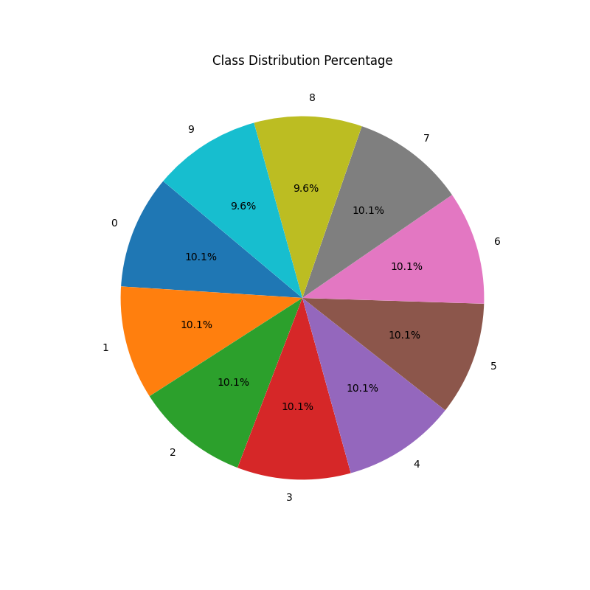

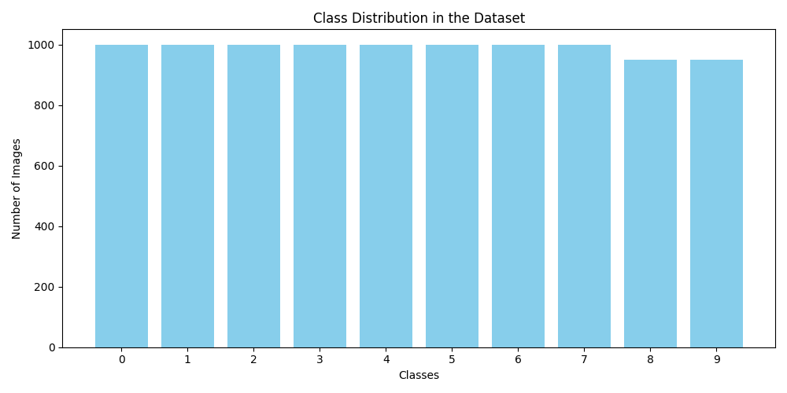

9.2 Test Cases



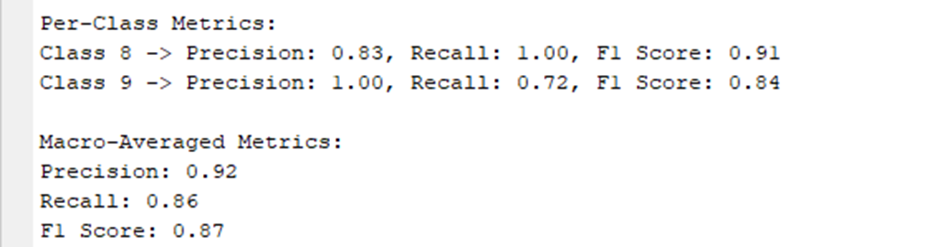

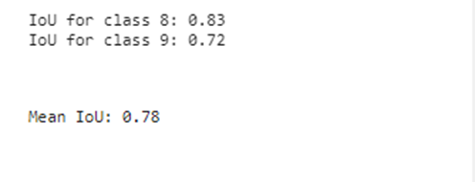

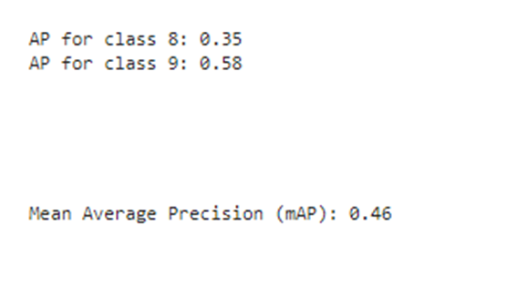

CHAPTER: 10
ADVANTAGES

10.1 Advantages
10.2 Limitations

10.1 Advantages
- The development and verification of an AI/ML-based application for onboard satellite image detection offer several key advantages. These benefits enhance the efficiency, reliability, and real-time processing capabilities of space-based image recognition systems. The major advantages are as follows:
- Improved Accuracy and Robustness:
- The AI/ML model is trained to handle various edge cases, ensuring reliable detection under different conditions such as noise, occlusion, and transformations.
- The extensive testing strategy enhances the model’s robustness against real-world variations in satellite imagery.
- Real-Time Processing on FPGA:
- Implementing the model on FPGA ensures real-time processing capabilities, which are crucial for onboard applications.
- Adaptability to Adverse Conditions:
- The developed test cases simulate real-world satellite imaging challenges such as illumination variations, motion blur, and compression artifacts.
- The AI model maintains high detection accuracy across different environmental conditions.
- Scalability and Flexibility
- The verification flow can be adapted for various onboard applications beyond image detection, such as classification.
- Enhanced Mission Reliability
- A well-tested AI/ML model increases the reliability of onboard applications, reducing the risk of mission failures due to erroneous detections.
- The verification flow ensures the system operates effectively even in unforeseen conditions.

- Contribution to Future AI-Based Space Systems
- The study and development of an AI verification framework set a foundation for future AI-driven space applications.
- The insights gained can be leveraged for further research in autonomous satellite operations and deep-space missions.
10.2 Limitations
- Sensitivity to Extreme Variation
- While tested under multiple edge cases, extreme environmental conditions (e.g., radiation effects, extreme illumination changes) may still pose challenges.
- Further robustness testing in space-like environments is necessary.
- Limited to Post-Development Modifications
- Once deployed in space, modifying or updating the model is challenging.
- Requires extensive pre-development testing and validation to ensure long-term reliability.
- Model Training
- Training AI models for space applications requires large, high-quality datasets, which may not always be available.

CHAPTER: 11
CONCLUSION AND FUTURE ENHANCEMENT

11.1 Conclusion
11.2 Future Enhancement

11.1 Conclusion
In conclusion, a Study & Development of Verification Flow for On-Board AI/ML Based Application system offers a multitude of benefits, including increased efficiency, improved time management, optimized resource utilization, better coordination, and valuable insights for decision-making. However, it's important to acknowledge the limitations associated with these systems, such as dependency on data accuracy, complexity, initial investment costs, integration challenges, and human factors.
Study & Development of Verification Flow for On-Board AI/ML Based Application system outweigh the challenges, particularly in today's fast-paced and competitive business environment. By leveraging technology to automate and streamline task management processes, organizations can enhance productivity, reduce errors, and improve overall project outcomes.
To maximize the effectiveness of a Study & Development of Verification Flow for On-Board AI/ML Based Application system, it's crucial to address potential challenges through proper planning, training, integration efforts, and ongoing maintenance. Additionally, fostering a culture of adaptability and open communication can help overcome resistance to change and ensure successful adoption of the system across the organization.
11.2 Future Enhancement
- FPGA-Based Model Deployment:
- The trained AI model will be converted into a hardware-friendly format using hardware description languages such as Register Transfer Level (RTL).
- Implementing the model in RTL would allow for its direct execution on FPGA hardware, ensuring optimized performance.
- The AI model can be synthesized and implemented on FPGA, taking advantage of parallel processing capabilities for faster inference times.
- Performance Evaluation on FPGA:
- Once the AI model is implemented in hardware, it must be evaluated against all predefined test case images.
- The performance metrics, such as inference time, accuracy, will be analyzed to determine the efficiency of FPGA-based execution.
- The comparison between software-based execution and hardware-based execution will provide insights into the advantages of FPGA acceleration for onboard AI/ML applications.
- Adaptive AI Model for Space Application:
- Future work can focus on adaptive AI models capable of self-improvement over time.
- Implementing online learning techniques will allow the model to fine-tune itself using newly captured satellite images.
- AI models can be optimized further to handle extreme environmental conditions with minimal degradation in performance.

BIBLIOGRAPHY

- Course Outcome
- Books
- Web Reference

Sr. No. | CO statement | Marks % weightage | Chapter No.
CO-1 | Undertake problem identification, formulation and solution | 20% | CHAPTER 1  INTRODUCTION
CO-2 | Design engineering solutions to complex problems utilising a systematic approach and team work | 30% | CHAPTER 2  SYSTEM REQUIREMENTS  CHAPTER 3  DAILY TASK
CO-3 | Communicate with engineers and the community at large in written and oral forms | 20% | CHAPTER 6  SYSTEM DESIGN  CHAPTER 10  ADVANTAGES  CHAPTER 11  CONCLUSION AND FUTURE ENHANCEMENT
CO-4 | Demonstrate the knowledge and understanding of engineering and management principle and apply it to assigned project | 30% | CHAPTER 4  FRONT END OF SYSTEM  CHAPTER 5  BACK END OF SYSTEM  CHAPTER 6  SYSTEM DESIGN  CHAPTER 7  DATA DICTIONARY  CHAPTER 8  TESTING
a. Course Outcome

b. Books:
- Fundamental of Software Engineering
  - Author: Rajib Mall
- The Joy of PHP Programming: A Beginner’s Guide to Programming Interactive Web Applications with PHP and MySQL
  - Author: Alan Forbes
- Head First PHP & MySQL
  - Author: Lynn Beighley & Michael Morrison
- SQL Server Database
  - Author: Mr.Gaurav Desani

c. Web Reference:
- W3Schools. "CSS Tutorial." [Online].
  - Available: https://www.w3schools.com/css/default.asp.. [Accessed: February 1, 2024].
- W3Schools. "JavaScript Tutorial." [Online].
  - Available: https://www.w3schools.com/js/default.asp. [Accessed: February 7, 2024].
- Javatpoint. “PHP Tutorial.”
  - [Online] Available: https://www.javatpoint.com/php-tutorial [Accessed: February 21, 2024].
- Free Code Camp. "Learn to code — for free." [Online].
  - Available: https://www.freecodecamp.org/ [Accessed: March 15, 2024].
- Stack Overflow. "Where Developers Learn, Share, & Build Careers." [Online].
  - Available: https://stackoverflow.com/ [Accessed: April 2, 2024]

